As they say a picture is worth a 1000 words Dylan’s Facebook post below is Leisurelink’s most liked social media post from a parent praising his interactions. The comments that followed the post clearly cements how many families have appreciated Dylan’s friendly approach at engaging with them.

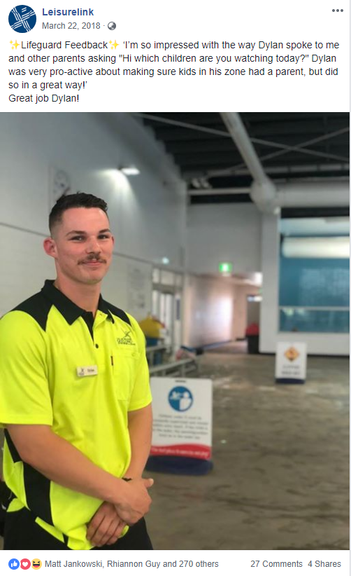

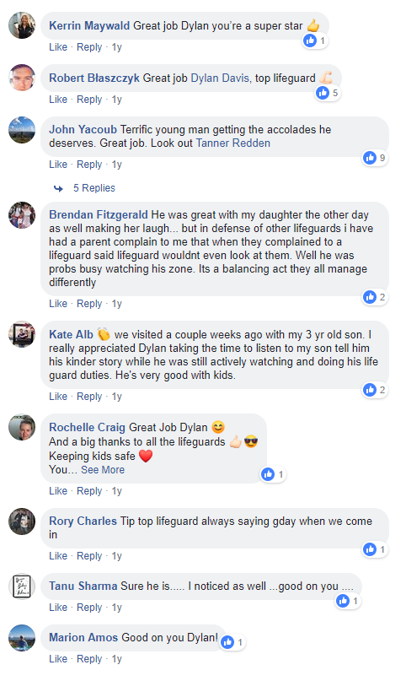
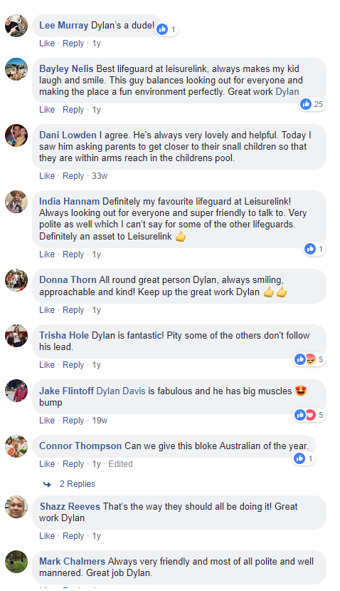
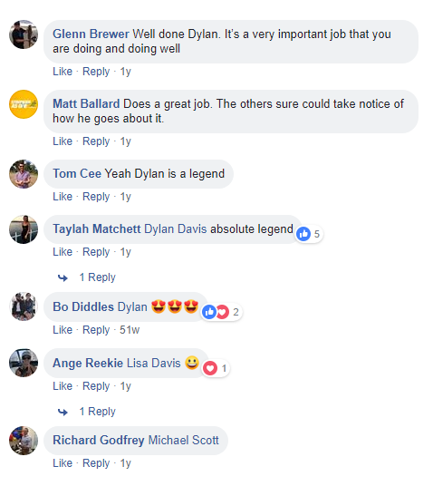

Dylan Davis has been a breath of fresh air since he started. Always putting his best foot forward on every shift. His willingness to learn and do the job to the best of his abilities is fantastic. You know when he is on pool deck it is going to be a great, smooth running shift. He is very reliable and is an inspiration to all the life guards around him. For example, he is constantly picking up when parents are not in the water with their children under 5 years of age, not only does he approach them straight away but he approaches them in such a kind and proper manner that the parents are more than willing to now get in the water and continue to do this on their returning visits. Rhi – Aquatic Team Leader

For me Dylan Davis has been a mentor in my growth and development as a lifeguard. He is someone who has been pivotal in my journey at Leisurelink.
Every shift I have had with Dylan results in me walking away, not only feeling as if I have completed my shift but as though I have made a difference. Dylan always remembers to thank his guards or congratulate them on their efforts and performance on the day.
A few weeks ago, Dylan approached me and congratulated me on completing the first few months as a lifeguard and told me how proud he was to see me develop and grow. To hear this from someone I respect and look up to, shows how Dylan cares about our improvement and confidence in becoming the best lifeguards we can.
Ensuring safety and well-being of every member of the Leisurelink community is an area Dylan shines in, whether this be simply checking in with every guard and asking the simple “How are you?” Or walking us to our cars after a close shift to make sure we are safe. These small acts of kindness should not go unnoticed and Dylan deserves to be recognised for his continuous commitment to the encouragement and development of others. Kiera- Lifeguard

Dylan’s main focus of being an active lifeguard is all about prevention and upskilling himself with ongoing training to ensure his skills remain up to date. He will regularly attend our internal training sessions not only to further his own knowledge but to assist with running the training. This passion for staff development saw Dylan compete with 3 other lifeguards from Leisurelink in the 2018 Platinum Pool Lifeguard Challenge. Rescue scenarios included the following:

- Dry and shallow spinal
- 200m swim and tow
- Seizure in the water with a lost child
- A Toddler choking
- Heart attack that required CPR and defib

After the day had passed Dylan was continuing to discuss the challenge with colleagues and preparing for to train our staff for next year.

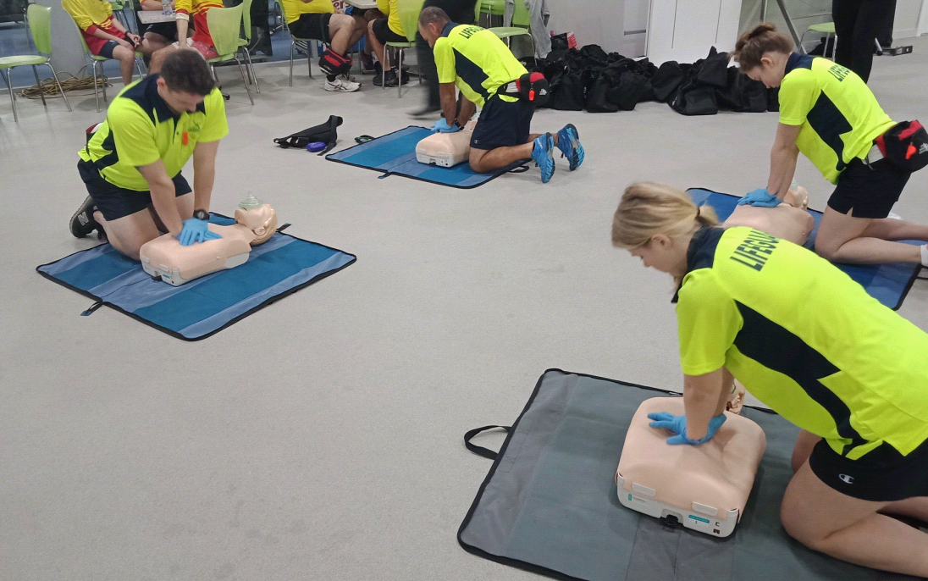
Dylan performing CPR at the Platinum Pool Lifeguard Challenge

